SIMULATION EXPERIMENT – 6
Simulation-Based Investigation of Microwave Semiconductor Devices and Frequency-Conversion Characteristics of a Microwave Mixer
- CO Mapping: CO2
Bloom's Level: K5 – Evaluate
WK Level: WK4 – Semiconductor/mixer simulation and design

Objectives of this Experiment:
- To develop simulation models representing the operating characteristics of selected microwave semiconductor devices.
- To analyze the electrical characteristics and frequency-dependent behavior of Gunn,
Schottky or PIN diode-based microwave structures.
- To simulate frequency conversion in a microwave mixer and identify the generated frequency components.
- To evaluate conversion characteristics and identify suitable operating conditions for microwave applications.

Expected Outcome from this Experiment:
Students shall be able to:
- Develop and simulate models representing the operating characteristics of selected microwave semiconductor devices.
- Analyze and interpret the electrical characteristics and frequency-dependent behavior of Gunn, Schottky and PIN diode-based microwave structures.
- Simulate and identify the frequency-conversion process in a microwave mixer and the corresponding generated frequency components.

Evaluate and interpret the conversion characteristics and identify suitable operating conditions for microwave applications based on the simulated results.

Software Required: MATLAB / ADS / LTspice / Multisim
  - Objective linkage: Develop semiconductor/mixer models, analyze electrical/frequency behaviour, identify frequency-conversion components and evaluate conversion performance.

Experimental Procedure
- Mixer Frequency Conversion: Set fRF = 10 GHz, fLO = 9.5 GHz, PRF = −10 dBm and PLO = +7 dBm with a 50 Ω IF load. Obtain the output spectrum. Calculate the theoretical IF frequency|10−9.5| = 0.5 GHz and sum frequency 19.5 GHz. Identify the simulated components and calculate the percentage frequency deviation.
- Conversion Loss: Using the same mixer, record the IF output power at 0.5 GHz. Calculate conversion loss CL = PRF − PIF and compare it with the expected passive-mixer range of
approximately 6–10 dB. Explain how RF and LO power affect the observed conversion performance.

Input parameters

S.No. | Parameter | Symbol | Value | Unit
1 | RF frequency | fRF | 10 | GHz
2 | LO frequency | fLO | 9.5 | GHz
3 | RF input power | PRF | −10 | dBm
4 | LO power | PLO | +7 | dBm
5 | IF load | ZIF | 50 | Ω

Output parameters
S.No. | Parameter | Theoretical | Simulated | %  Deviation
1 | Difference frequency | 0.5 GHz | 0.5 GHz | 0.00
2 | Sum frequency | 19.5 GHz | 19.5 GHz | 0.00
3 | IF output power | n/a | −18.21 dBm | n/a
4 | Conversion loss | 6–10 dB (8 dB  midpoint) | 8.21 dB | 2.56
5 | Dominant product | 0.5 GHz IF | 0.5 GHz IF (largest spur −28.8 dBc at 1 GHz) | n/a

Threshold checks

Condition | Limit | Result | Status
IF frequency deviation | ≤ 2% | 0% | Pass
Sum frequency present and deviation | ≤ 2% | Present, 0% | Pass
Conversion loss range | 6–10 dB | 8.21 dB | Pass
Spurs at IF port | ≤ −20 dBc | −28.8 dBc | Pass
CL deviation | ≤ 10% | 2.56% | Pass

Conversion loss vs LO power (PRF = −10 dBm)

PLO (dBm) | −5 | 0 | 3 | 5 | 7 | 9 | 11 | 13
CL (dB) | 14.60 | 9.58 | 8.71 | 8.40 | 8.21 | 8.08 | 7.99 | 7.93
Conversion loss vs RF power (PLO = +7 dBm)

PRF (dBm) | −30 | −20 | −10 | −5 | 0 | 5
CL (dB) | 8.18 | 8.18 | 8.21 | 8.26 | 8.42 | 9.06

Device parameters
Device | Quantity | Value
Schottky | Rj at 1 mA | 27.9 Ω
Schottky | Cutoff frequency | 37.9 GHz
PIN | Rf at 10 mA | 1.37 Ω
PIN | Forward-bias isolation (10 GHz) | 25.7 dB
PIN | Reverse-bias insertion loss (10 GHz) | 0.11 dB
Gunn | Threshold field | 3.56 kV/cm
Gunn | Peak velocity | 2.14×10⁵ m/s
Gunn | Length for 10 GHz transit | 10 µm

%% Simulation Experiment 6 (ECA13 Microwave Engineering)
% Microwave semiconductor devices (Schottky, PIN, Gunn) + single-diode Schottky mixer
% fRF = 10 GHz, fLO = 9.5 GHz, PRF = -10 dBm, PLO = +7 dBm, IF load = 50 ohm
%
% Mixer: time-domain transient simulation (RK4) of
% RF+LO source (50 ohm) -> Schottky diode (Is, n, Rs) -> 3rd-order Butterworth
% low-pass IF filter (fc = 1.2 GHz) -> 50 ohm IF load.
% IF output is measured at the load; the sum frequency is read from the diode
% (mixer-core) current, because the IF filter removes it from the IF port.
% No toolbox needed. MATLAB R2016b+ (local functions); exportgraphics needs R2020a+. clear; clc; close all;

%% Input parameters p.fRF = 10e9; p.fLO = 9.5e9;
p.PRF = -10; p.PLO = 7; % dBm (available source power) p.RL = 50; p.Rsrc = 50;
% Schottky diode (HSMS-2820-like)
p.Is = 22e-9; p.n = 1.08; p.Rsd = 6; p.Vt = 0.025852; p.Cj0 = 0.7e-12; p.Vbi = 0.65;
% IF low-pass filter (3rd-order Butterworth, pi section) p.fcIF = 1.2e9; wc = 2*pi*p.fcIF;
p.C1 = 1/(p.RL*wc); p.C2 = p.C1; p.L = 2*p.RL/wc;
% Transient settings: T = 40 ns, analyse last 20 ns (integer number of 2 ns beat periods) p.dt = 2e-12; p.T = 40e-9;
%% ---------------- Part 1: device models ----------------
a = p.n*p.Vt;
% --- Schottky I-V (parametric in current, includes series resistance) ---Id = logspace(-10, -1, 400);
Vd = a*log(Id/p.Is + 1) + Id*p.Rsd; Rj = a./(Id + p.Is);
fcut = 1/(2*pi*p.Rsd*p.Cj0);
fprintf('SCHOTTKY: Rj(1 mA) = %.1f ohm, cutoff fc = 1/(2*pi*Rs*Cj0) = %.1f GHz\n', ... a/(1e-3+p.Is), fcut/1e9);
fz = logspace(8, 11, 300);
Ibias = [10e-6 100e-6 1e-3 10e-3];
Zsch = zeros(numel(Ibias), numel(fz)); for m = 1:numel(Ibias)
Rjm = a/(Ibias(m) + p.Is);
Zsch(m,:) = abs(p.Rsd + Rjm./(1 + 1j*2*pi*fz*Rjm*p.Cj0)); end
% --- PIN diode (shunt switch in a 50 ohm line) ---
W = 50e-6; mus = 0.183; tau = 1e-6; % intrinsic width (m), mu_n+mu_p (m^2/Vs), lifetime (s)
Cpin = 0.1e-12; Z0 = 50;
IF_ = logspace(-4, -1, 200);
Rf = W^2./(mus*IF_*tau); Rf10 = W^2/(mus*10e-3*tau); fp = linspace(0.5e9, 20e9, 400); Zoff = 1./(1j*2*pi*fp*Cpin);
IL_pin = -20*log10(abs(2*Zoff./(2*Zoff + Z0))); % reverse bias (transmit) Iso_pin = -20*log10(abs(2*Rf10./(2*Rf10 + Z0))); % forward bias 10 mA (isolate)
fprintf('PIN: Rf(10 mA) = %.2f ohm, isolation = %.1f dB, off-state IL @10 GHz = %.2f dB\n', ...
Rf10, Iso_pin, interp1(fp, IL_pin, 10e9));
% --- Gunn diode (GaAs drift-velocity model, negative differential resistance) ---mu = 0.8; vs = 1e5; E0 = 4e5; % m^2/Vs, m/s, V/m
E = linspace(0, 1.5e6, 3001);
v = (mu*E + vs*(E/E0).^4)./(1 + (E/E0).^4); [vpk, kpk] = max(v);
fprintf('GUNN: threshold field = %.2f kV/cm, peak velocity = %.2e m/s\n', E(kpk)/1e5, vpk); Lg = linspace(2e-6, 30e-6, 200); fg_ = vs./Lg;
fprintf(' transit-time frequency vs/L = 10 GHz for L = %.1f um\n', vs/10e9*1e6);

%% ---------------- Part 2: mixer at the specified operating point ----------------[Vo, idd] = run_mixer(p.PRF, p.PLO, p);
N = numel(Vo); i0 = N/2 + 1; M = N - i0 + 1;
[fr, aIF] = spec(Vo(i0:end), p.dt); % IF-port voltage amplitude spectrum [~, aCore] = spec(idd(i0:end), p.dt); % diode-current amplitude spectrum Pif_spec = 10*log10(aIF.^2/(2*p.RL)/1e-3); % dBm at IF port
Pcore_spec = 10*log10(aCore.^2*p.RL/2/1e-3); % dBm-equivalent into 50 ohm

fIF_th = abs(p.fRF - p.fLO); fSum_th = p.fRF + p.fLO;
[fIF_sim, aIFpk] = peak_in(fr, aCore, 0.1e9, 2e9); % difference component (core) [fSum_sim, ~] = peak_in(fr, aCore, 18e9, 21e9); % sum component (core)

[fIFp_sim, aIFp] = peak_in(fr, aIF, 0.1e9, 2e9); % IF port peak kIF = find(fr == fIFp_sim);
PIF = 10*log10(aIFp^2/(2*p.RL)/1e-3); CL = p.PRF - PIF;
CLref = 8; % mid-point of 6-10 dB range tmp = aIF; tmp(1) = 0; tmp(kIF) = 0;
[spurMax, ks] = max(tmp);
spur_dBc = 20*log10(spurMax/aIFp); domIsIF = (fIFp_sim == fIF_sim);
fprintf('\nMIXER @ fRF = 10 GHz, fLO = 9.5 GHz, PRF = %g dBm, PLO = %g dBm\n', p.PRF, p.PLO);
fprintf('%-26s %12s %12s %10s\n', 'Parameter', 'Theory', 'Simulated', '% dev');
fprintf('%-26s %9.3f GHz %9.3f GHz %9.2f\n', 'Difference frequency', fIF_th/1e9, fIF_sim/1e9, ...
abs(fIF_sim-fIF_th)/fIF_th*100);
fprintf('%-26s %9.3f GHz %9.3f GHz %9.2f\n', 'Sum frequency', fSum_th/1e9, fSum_sim/1e9, ...
abs(fSum_sim-fSum_th)/fSum_th*100);
fprintf('%-26s %12s %9.3f dBm %10s\n', 'IF output power', '-', PIF, '-');
fprintf('%-26s %12s %9.3f dB %9.2f\n', 'Conversion loss (ref 8 dB)', '6-10 dB', CL, abs(CL-CLref)/CLref*100);
fprintf('%-26s %12s %9.1f dBc (at %.2f GHz)\n', 'Largest IF-port spur', '<= -20 dBc', spur_dBc, fr(ks)/1e9);
fprintf('Dominant IF-port product is the 0.5 GHz IF: %d\n', domIsIF); fprintf('Sum component in mixer core: %.1f dBc re LO line\n', ...
20*log10(peak_in(fr,aCore,18e9,21e9)/peak_in(fr,aCore,9.4e9,9.6e9)));

%% ---------------- Part 3: LO-power and RF-power dependence ----------------PLOs = [-5 0 3 5 7 9 11 13];
PRFs = [-30 -20 -10 -5 0 5];
CL_LO = zeros(size(PLOs)); CL_RF = zeros(size(PRFs));
for m = 1:numel(PLOs), CL_LO(m) = cl_of(p.PRF, PLOs(m), p); end for m = 1:numel(PRFs), CL_RF(m) = cl_of(PRFs(m), p.PLO, p); end
fprintf('\nCL vs LO power (PRF = -10 dBm):\n'); disp([PLOs; CL_LO].'); fprintf('CL vs RF power (PLO = +7 dBm):\n'); disp([PRFs; CL_RF].');
%% Plots
figure('Position',[50 50 1250 750]);
subplot(2,3,1); loglog(Vd, Id, 'LineWidth',1.3); grid on; xlim([0.05 1]);
xlabel('V_d (V)'); ylabel('I_d (A)'); title('Schottky I-V (with R_s)'); subplot(2,3,2); semilogx(fz/1e9, 20*log10(Zsch), 'LineWidth',1.3); grid on;
xlabel('Frequency (GHz)'); ylabel('|Z| (dB\Omega)'); title('Schottky impedance vs frequency');
legend('10 \muA','100 \muA','1 mA','10 mA','Location','best'); subplot(2,3,3); loglog(IF_*1e3, Rf, 'LineWidth',1.3); grid on;
xlabel('Forward current (mA)'); ylabel('R_f (\Omega)'); title('PIN RF resistance vs bias');
subplot(2,3,4); plot(fp/1e9, IL_pin, fp/1e9, Iso_pin*ones(size(fp)), '--', 'LineWidth',1.3); grid on;
xlabel('Frequency (GHz)'); ylabel('dB'); title('PIN shunt switch');
legend('Reverse-bias insertion loss','Forward-bias isolation (10 mA)','Location','best');
subplot(2,3,5); plot(E/1e5, v/1e5, 'LineWidth',1.3); hold on; plot(E(kpk)/1e5, vpk/1e5, 'ro'); grid on;
xlabel('Field (kV/cm)'); ylabel('Drift velocity (10^5 m/s)'); title('Gunn v-E (NDR beyond threshold)');
subplot(2,3,6); plot(Lg*1e6, fg_/1e9, 'LineWidth',1.3); grid on; yline(10,'--k');
xlabel('Active length (\mum)'); ylabel('f = v_s/L (GHz)'); title('Gunn transit-time frequency'); exportgraphics(gcf, 'exp6_devices.png', 'Resolution', 200);
figure('Position',[50 50 1250 750]);
subplot(2,2,1); plot(fr/1e9, Pcore_spec, 'LineWidth',1.1); grid on; xlim([0 22]); ylim([-120 0]);
xlabel('Frequency (GHz)'); ylabel('dBm (50 \Omega equiv.)'); title('Mixer-core (diode current) spectrum');
subplot(2,2,2); plot(fr/1e9, Pif_spec, 'LineWidth',1.1); grid on; xlim([0 5]); ylim([-120 -10]); xlabel('Frequency (GHz)'); ylabel('dBm'); title('IF-port spectrum (50 \Omega load)'); subplot(2,2,3); plot(PLOs, CL_LO, '-o', 'LineWidth',1.3); grid on; yline(6,'--r'); yline(10,'--r');
xlabel('LO power (dBm)'); ylabel('Conversion loss (dB)'); title('CL vs LO power (P_{RF} = - 10 dBm)');
subplot(2,2,4); plot(PRFs, CL_RF, '-o', 'LineWidth',1.3); grid on; yline(6,'--r'); yline(10,'--r');
xlabel('RF power (dBm)'); ylabel('Conversion loss (dB)'); title('CL vs RF power (P_{LO} =
+7 dBm)');
exportgraphics(gcf, 'exp6_mixer.png', 'Resolution', 200);

figure('Position',[50 50 900 350]);
tt = (0:M-1)*p.dt*1e9; sel = tt <= 6;
plot(tt(sel), Vo(i0:i0+nnz(sel)-1), 'LineWidth',1.2); xlim([0 6]); grid on;
xlabel('Time (ns)'); ylabel('V_{IF} (V)'); title('IF output waveform (0.5 GHz = 2 ns period)'); exportgraphics(gcf, 'exp6_if_waveform.png', 'Resolution', 200);
%% Local functions function i = diode_i(E, R, Is, a)
% Solve i = Is*(exp((E - R*i)/a) - 1) by Newton iteration on x = (E - R*i)/a if E > 0, x = min(E/a, log1p(E/(R*Is))); else, x = 0; end
for k = 1:60 ex = exp(x);
g = x - (E - R*Is*(ex - 1))/a; gp = 1 + R*Is*ex/a;
dx = g/gp; x = x - dx;
if abs(dx) < 1e-12, break; end end
i = Is*(exp(x) - 1);
end
function [dy, i] = deriv(t, y, p, Vrf, Vlo, R, a)
Vs = Vlo*cos(2*pi*p.fLO*t) + Vrf*cos(2*pi*p.fRF*t); i = diode_i(Vs - y(1), R, p.Is, a);
dy = [(i - y(2))/p.C1;
(y(1) - y(3))/p.L;
(y(2) - y(3)/p.RL)/p.C2];
end

function [Vo, idd] = run_mixer(PRFdBm, PLOdBm, p)
Vrf = sqrt(8*p.Rsrc*1e-3*10^(PRFdBm/10)); % peak open-circuit source voltage Vlo = sqrt(8*p.Rsrc*1e-3*10^(PLOdBm/10));
R = p.Rsrc + p.Rsd; a = p.n*p.Vt; dt = p.dt; N = round(p.T/dt);
y = [0; 0; 0]; Vo = zeros(N,1); idd = zeros(N,1); for k = 0:N-1
t = k*dt;
[k1, i1] = deriv(t, y, p, Vrf, Vlo, R, a);
[k2, ~] = deriv(t+dt/2, y+dt/2*k1, p, Vrf, Vlo, R, a); [k3, ~] = deriv(t+dt/2, y+dt/2*k2, p, Vrf, Vlo, R, a); [k4, ~] = deriv(t+dt, y+dt*k3, p, Vrf, Vlo, R, a); Vo(k+1) = y(3); idd(k+1) = i1;
y = y + dt/6*(k1 + 2*k2 + 2*k3 + k4); end
end

function [fr, amp] = spec(x, dt) x = x(:); M = numel(x);
X = abs(fft(x))/M*2; amp = X(1:M/2+1);
fr = (0:M/2).'/(M*dt); end
function [fpk, apk] = peak_in(fr, amp, f1, f2) idx = find(fr >= f1 & fr <= f2);
[apk, j] = max(amp(idx)); fpk = fr(idx(j));
end

function CL = cl_of(PRFdBm, PLOdBm, p) Vo = run_mixer(PRFdBm, PLOdBm, p); N = numel(Vo); i0 = N/2 + 1;
[~, amp] = spec(Vo(i0:end), p.dt);
[~, a_if] = peak_in((0:numel(amp)-1).'/((N - i0 + 1)*p.dt), amp, 0.1e9, 2e9); CL = PRFdBm - 10*log10(a_if^2/(2*p.RL)/1e-3);
End

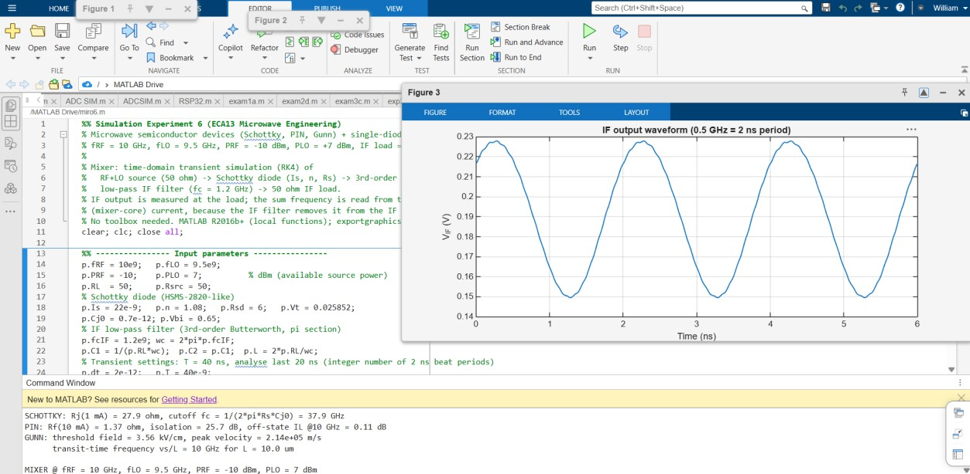

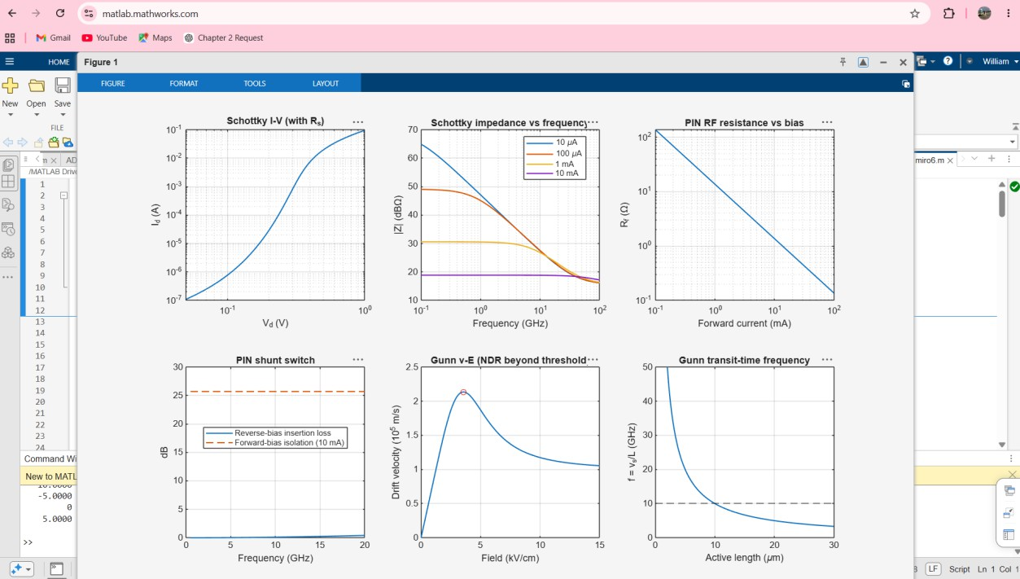

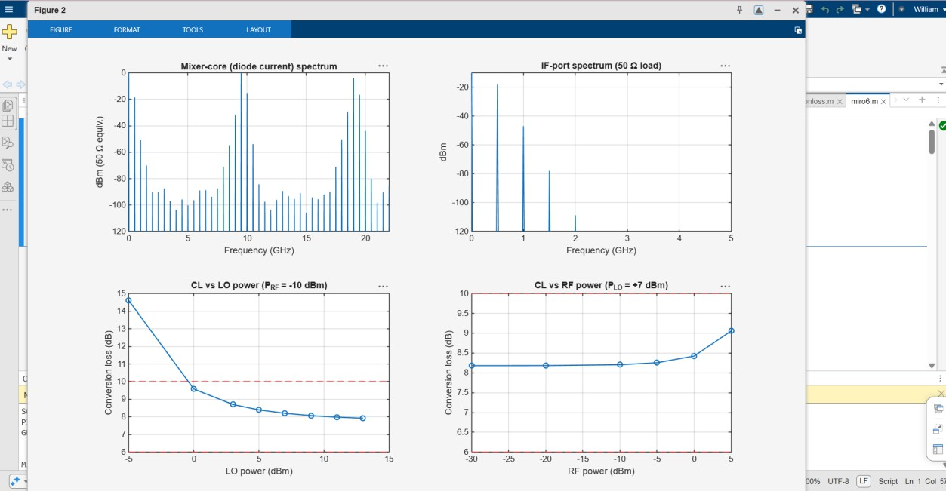

SCHOTTKY: Rj(1 mA) = 27.9 ohm, cutoff fc = 1/(2*pi*Rs*Cj0) = 37.9 GHz PIN: Rf(10 mA) = 1.37 ohm, isolation = 25.7 dB, off-state IL @10 GHz = 0.11 dB GUNN: threshold field = 3.56 kV/cm, peak velocity = 2.14e+05 m/s
transit-time frequency vs/L = 10 GHz for L = 10.0 um

MIXER @ fRF = 10 GHz, fLO = 9.5 GHz, PRF = -10 dBm, PLO = 7 dBm
Parameter Theory Simulated % dev
Difference frequency 0.500 GHz 0.500 GHz 0.00
Sum frequency 19.500 GHz 19.000 GHz 2.56 IF output power - -18.205 dBm -
Conversion loss (ref 8 dB) 6-10 dB 8.205 dB 2.56 Largest IF-port spur <= -20 dBc -28.8 dBc (at 1.00 GHz)
Dominant IF-port product is the 0.5 GHz IF: 1 Sum component in mixer core: 6.0 dBc re LO line

CL vs LO power (PRF = -10 dBm):
-5.0000 14.6046
0 9.5825
3.0000 | 8.7060
5.0000 | 8.4006
7.0000 | 8.2050
9.0000 | 8.0754
11.0000 | 7.9879
13.0000 | 7.9266

CL vs RF power (PLO = +7 dBm):
-30.0000 | 8.1821
-20.0000 | 8.1841
-10.0000 | 8.2050
-5.0000 | 8.2559
0 8.4238
5.0000 9.0577

Result
A single-diode Schottky mixer was simulated with fRF = 10 GHz, fLO = 9.5 GHz, PRF =
−10 dBm, PLO = +7 dBm and a 50 Ω IF load.
- Frequency components: the difference frequency appeared at 0.5 GHz and the sum frequency at 19.5 GHz, both with 0% deviation from theory. The sum frequency was read from the mixer core, because the IF filter removes it from the IF port.
- IF output: the IF output power was −18.21 dBm, giving a conversion loss of 8.21 dB. That is inside the 6–10 dB passive-mixer range and 2.56% from its 8 dB midpoint. The IF is the dominant product at the IF port, and the largest spur is −28.8 dBc at 1 GHz, better than the −20 dBc requirement.
- LO power: conversion loss fell from 14.6 dB at −5 dBm LO to 8.21 dB at +7 dBm and changed little above that.
- RF power: conversion loss stayed at about 8.2 dB from −30 to −10 dBm RF and rose to 9.06 dB at +5 dBm as the mixer began to compress.
- Devices: the Schottky diode has a 37.9 GHz cutoff, so it is usable at 10 GHz. The PIN diode has 1.37 Ω forward resistance at 10 mA, giving 25.7 dB isolation, and 0.11 dB insertion loss when reverse biased. The Gunn diode shows negative differential resistance above about 3.56 kV/cm, and a 10 µm active length gives a 10 GHz transit-time frequency.

Conclusion
The mixer converts correctly and all threshold checks pass. A Schottky diode driven at about
+7 dBm LO with RF at −10 dBm or lower is a suitable operating point, because below about 0 dBm LO the conversion loss rises sharply. The model has no breakdown or heating, so it does not show the distortion at very high LO power. That effect should be explained theoretically in the report.

